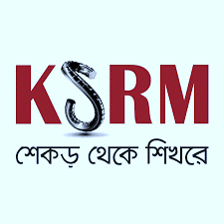

**Half-day hartal in Narayanganj tomorrow**

**B1**

Plus 8 Page Tabloid on App Savvy Bangladesh

**DHAKA THURSDAY NOVEMBER 16, 2024**

Tk 15.00

www.thedailystar.net

Regd No. DA 781 VotXXXIV No. 131 AGRAHAYAN 2,1431 BS ZbQND 21.145 16 Page Plus Rising Start: 



**Price hike has made general people’s life miserable**

**P3**

**Australia dominate Pakistan in truncated T20I series-opener**

**P7**

**Dengue crisis: How many lives must be lost before action is taken?**

**P11**

**No need for yearly climate summit: Prof Yunus**

**BNP will restore freedom of expression if people give mandate: Tarique**

**Gambler hits $85 mln jackpot betting on Trump win**

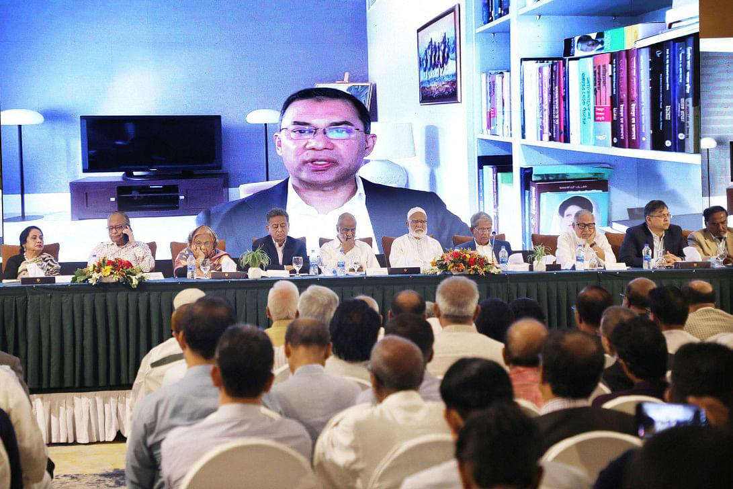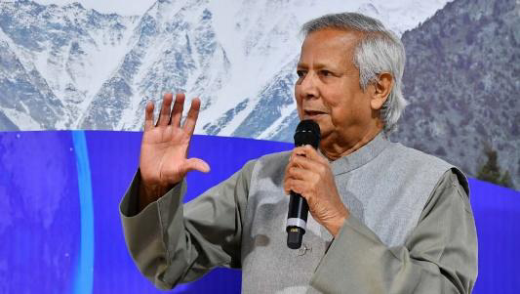

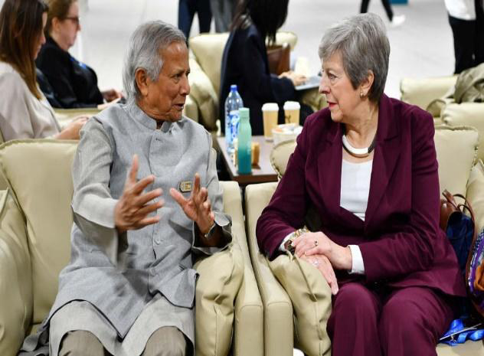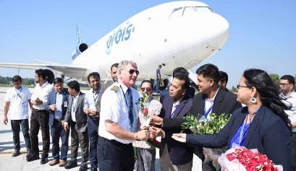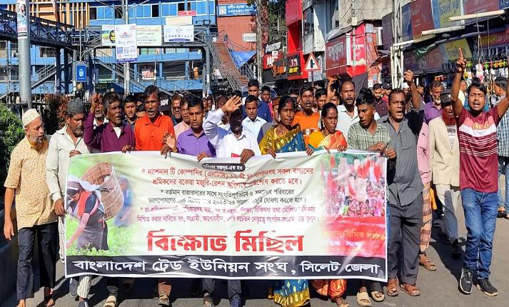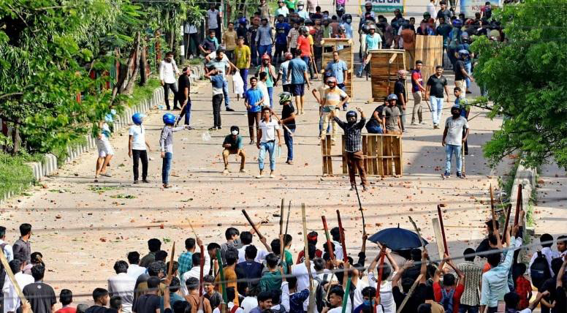

Chief Adviser Professor Muhammad Yunus, at the COP29 summit, today said the climate conference does not need to be held every year because the goals of such summits are known. He also urged the world to make a long-term plan for meeting those.

**Next at p12**

Prof Yunus meets former British PM Theresa May on the sidelines of COP29 in Baku, Azerbaijan on Thursday, November 14, 2024. Photo: PID

Chief Adviser Prof Muhammad Yunus today said that approximately 1,500 students, workers, and citizens lost their lives during the July uprising, with 19,931 others injured. Addressing the nation on the 100-day milestone of the interim government, the chief adviser said, "Our government has been meticulously collecting information on each death…

**Next at p03**

BNP Acting Chairman Tarique Rahman today said if his party forms government through a public mandate in the future, the foundation of the country's governance will be the rule of law, human rights, and freedom of expression.

**Next at p07**

**Chief adviser returns home after joining COP29 in Baku**

Chief Adviser Professor Muhammad Yunus returned home this evening wrapping up his Baku tour to attend the global climate meet Conference of Parties-29 (COP29). "A flight of Biman Bangladesh Airlines carrying the chief adviser

**Next at p02**

**Ranieri comes out of retirement to lead hometown club Roma**

Claudio Ranieri took charge of his hometown team Roma on Thursday, coming out of retirement to become the Serie A club's third coach of a troubled season.

**Next at p09**

Link: https://www.thedailystar.net/

**Orbis Flying Eye Hospital arrives Chattogram**

Orbis Flying Eye Hospital, the world's only fully accredited ophthalmic teaching and surgical hospital onboard an aircraft, arrived today in Bangladesh to conduct training on ophthalmology.

**Next at p10**

**5 more die of dengue, over 1,100 hospitalised**

At least five dengue patients died in the last 24 hours, while 1,107 new patients were hospitalised as of this morning. Of the five deaths, two were reported in Barishal division, and one each in Dhaka South City…

**Next at p10**

A man made $85 million in a series of wagers on Polymarket, a crypto-based prediction market that was a popular platform for betting on the US election won by Donald Trump, a blockchain analysis firm told AFP Wednesday.

**Next at p06**

**Tea workers in Sylhet stage protest demanding arrears**

Hundreds of tea workers took to the streets of Sylhet today, demanding the immediate payment of unpaid wages and rations. Organized by the Sylhet District branch of the Bangladesh Trade Union Centre, the protest march highlighted the dire financial and humanitarian crisis faced by thousands of workers from tea estates across the region.

**Next at p04**

**1,500 dead, nearly 20,000 injured in July uprising: Yunus**